

**NAME: AKHIL**

**Reg No: 11703357**

**E-mail**: [akhildhiman141@gmail.com](mailto:akhildhiman141@gmail.com)

**Git Hub**: <https://github.com/akhildhiman7/Student-Teacher-Problem.git>

## INDEX

|  |  |  |
| --- | --- | --- |
| **S. No** | **Title** | **Pg. No** |
| 1. | Code | 3 |
| 2. | Problem in terms of Operating System. | 9 |
| 3. | Algorithm | 9 |
| 4. | Complexity | 10 |
| 5. | Constraint Limit | 12 |
| 6. | Condition | 12 |
| 7. | Test Case | 12 |

**CODE:** (Python Implementation)

class StudentQueue:

def __init__(self):

self.items = []

def isEmpty(self):

return self.items == []

def enqueue(self, item, AT, BT):

self.lst = []

self.lst.append(item)

self.lst.append(AT)

self.lst.append(BT)

self.items.insert(0,self.lst)

def dequeue(self):

return self.items.pop()

def size(self):

return len(self.items)

def head(self):

return self.items[-1][1]

def burst_time(self):

return self.items[-1][2]

def id_no(self):

return self.items[-1][0]

class TeacherQueue:

def __init__(self):

self.items = []

def isEmpty(self):

return self.items == []

def enqueue(self, item, AT, BT):

self.lst = []

self.lst.append(item)

self.lst.append(AT)

self.lst.append(BT)

self.items.insert(0,self.lst)

def dequeue(self):

return self.items.pop()

def size(self):

return len(self.items)

def head(self):

return self.items[-1][1]

def burst_time(self):

return self.items[-1][2]

def id_no(self):

return self.items[-1][0]

SQ = StudentQueue()

TQ = TeacherQueue()

print("0. Automatic")

print("1. User Provided")

#ip_var = int(input("Mode of input: "))

ip_var = 1

if ip_var == 0:

print("Automatic Mode Selected")

print()

Tat1, Tbt1 = 1, 2

Tat2, Tbt2 = 2, 2

Tat3, Tbt3 = 3, 2

Tat4, Tbt4 = 14, 3

TQ.enqueue(1, Tat1, Tbt1)

TQ.enqueue(2, Tat2, Tbt2)

TQ.enqueue(3, Tat3, Tbt3)

TQ.enqueue(4, Tat4, Tbt4)

Sat1, Sbt1 = 1, 2

Sat2, Sbt2 = 2, 2

SQ.enqueue(1, Sat1, Sbt1)

SQ.enqueue(2, Sat2, Sbt2)

teachers = TQ.size()

students = SQ.size()

else:

print("User Mode Selected")

print()

teachers = int(input("Enter the number of Teachers in the queue: ", ))

t_data = []

last_time = 0

if teachers != 0:

for i in range(teachers):

print("Enter Arrival Time for Teacher ",i+1, end = "")

AT = int(input())

if (AT < last_time):

while True:

print("AT can't be less then previous arrival time")

print("Enter Arrival Time for Teacher ",i+1, end = "")

AT = int(input())

if last_time <= AT:

break

last_time = AT

print("Enter Burst Time for Teacher ",i+1, end = "")

BT = int(input())

if BT <= 0:

while True:

print("Error: BT can't be less than 1 ##Min BT req: 1")

print("Enter Burst Time for Teacher ",i+1, end = "")

BT = int(input())

if BT > 0:

break

temp_list = []

temp_list.append(AT)

temp_list.append(BT)

t_data.append(temp_list)

students = int(input("Enter the nubers of Students in the queue: ", ))

s_data = []

last_time = 0

if students != 0:

for i in range(students):

print("Enter Arrival Time for Student ",i+1, end = "")

AT = int(input())

if (AT < last_time):

while True:

print("AT can't be less then previous arrival time")

print("Enter Arrival Time for Student ",i+1, end = "")

AT = int(input())

if last_time <= AT:

break

last_time = AT

print("Enter Burst Time for Student ",i+1, end = "")

BT = int(input())

if BT <= 0:

while True:

print("Error: BT can't be less than 1 ##Min BT req: 1")

print("Enter Burst Time for Teacher ",i+1, end = "")

BT = int(input())

if BT > 0:

break

temp_list = []

temp_list.append(AT)

temp_list.append(BT)

s_data.append(temp_list)

for i in range (teachers):

TQ.enqueue(i+1, t_data[i][0], t_data[i][1])

for i in range(students):

SQ.enqueue(i+1, s_data[i][0], s_data[i][1])

maxlen =teachers+students

student_priority = 0

curr_time = min(SQ.head(), TQ.head())

t = teachers

s = students

j = 0

k = 0

'''

print("No of teachers: ", t)

print("No of students: ", s)

print("AT of first student is ", SQ.items[s-1][1])

print("AT of first teacher is ", TQ.items[t-1][1])

'''

for i in range(maxlen):

if (SQ.isEmpty()):

for i in range (teachers):

if TQ.isEmpty() == False:

print("Teacher ",TQ.id_no()," issued book")

curr_time += TQ.burst_time()

TQ.dequeue()

break

elif TQ.isEmpty():

for i in range (students):

if SQ.isEmpty() == False:

print("Student ",SQ.id_no()," issued book")

curr_time += SQ.burst_time()

SQ.dequeue()

break

elif student_priority == 2:

print("Student ",SQ.id_no()," issued book")

curr_time += SQ.burst_time()

student_priority = 0

SQ.dequeue()

else:

tchr = TQ.head()

stdnt = SQ.head()

if tchr <= stdnt:

if curr_time >= stdnt:

student_priority += 1

print("Teacher ", TQ.id_no()," issued book. Student Priority: ", student_priority)

curr_time += TQ.burst_time()

TQ.dequeue()

elif tchr > stdnt:

if curr_time >= tchr:

student_priority += 1

curr_time += TQ.burst_time()

print("Teacher ", TQ.id_no()," issued book. Student Priority: ", student_priority)

TQ.dequeue()

else:

curr_time += SQ.burst_time()

print("Student ", SQ.id_no()," issued book")

student_priority = 0

SQ.dequeue()

**Ques1. Explain the problem in terms of Operating System Concept?**

**Description:**

There are two queues for two different type of processes which are represented by Teachers and Students and we may call the queues be TeacherQueue and StudentQueue which can enter in a library for issuing of books. But the issuer can handle only one request at a time either be it Student or Teacher. If a Student is already in the line and issuing a book than if a teacher comes than that Teacher will be the second person to get the book issued. But if a Teacher is already in the queue and a student and a teacher comes together in their queues. The teacher will be the one who will be given the priority to get the book issued. A student may wait if a Teacher is already in the queue. This situation may lead to aging of Student so the task was to minimize the waiting time of Student.

**Ques2. Write the algorithm for proposed solution for the assigned problem.**

**Algorithm:**

SET maxlen = len(Student Queue) + len(Teacher Queue)

for i in range(maxlen): #Iterate the loop in the range of maxlen

if (SQ.isEmpty()): # Check if Student Queue is empty

for i in range (teachers):

if TQ.isEmpty() == False: #Check if Teacher Queue is not empty

print("Teacher ",TQ.id_no()," issued book")

curr_time += TQ.burst_time()

TQ.dequeue()

break

elif TQ.isEmpty():

for i in range (students):

if SQ.isEmpty() == False:

print("Student ",SQ.id_no()," issued book")

curr_time += SQ.burst_time()

SQ.dequeue()

break

elif student_priority == 2:

print("Student ",SQ.id_no()," issued book")

curr_time += SQ.burst_time()

student_priority = 0

SQ.dequeue()

else:

tchr = TQ.head()

stdnt = SQ.head()

if tchr <= stdnt:

if curr_time >= stdnt:

student_priority += 1

print("Teacher ", TQ.id_no()," issued book. Student Priority: ", student_priority)

curr_time += TQ.burst_time()

TQ.dequeue()

elif tchr > stdnt:

if curr_time >= tchr:

student_priority += 1

curr_time += TQ.burst_time()

print("Teacher ", TQ.id_no()," issued book. Student Priority: ", student_priority)

TQ.dequeue()

else:

curr_time += SQ.burst_time()

print("Student ", SQ.id_no()," issued book")

student_priority = 0

SQ.dequeue()

**Ques3. Calculate complexity of implemented algorithm.**

**Complexity:**

for i in range(maxlen): // O(N)

if (SQ.isEmpty()): // O(1)

for i in range (teachers): // O(N)

if TQ.isEmpty() == False: // O(1)

print("Teacher ",TQ.id_no()," issued book") // O(1)

curr_time += TQ.burst_time() // O(1)

TQ.dequeue()// O(1)

break

elif TQ.isEmpty():// O(1)

for i in range (students): // O(N)

if SQ.isEmpty() == False: // O(1)

print("Student ",SQ.id_no()," issued book") // O(1)

curr_time += SQ.burst_time() // O(1)

SQ.dequeue() // O(1)

break // O(1)

elif student_priority == 2: // O(1)

print("Student ",SQ.id_no()," issued book") // O(1)

curr_time += SQ.burst_time()// O(1)

student_priority = 0 // O(1)

SQ.dequeue() // O(1)

else: // O(1)

tchr = TQ.head() // O(1)

stdnt = SQ.head() // O(1)

if tchr <= stdnt: // O(1)

if curr_time >= stdnt: // O(1)

student_priority += 1 // O(1)

print("Teacher ", TQ.id_no(),"issued book. Student Priority:",student_priority) // O(1)

curr_time += TQ.burst_time()// O(1)

TQ.dequeue()// O(1)

elif tchr > stdnt: // O(1)

if curr_time >= tchr: // O(1)

student_priority += 1 // O(1)

curr_time += TQ.burst_time()// O(1)

print("Teacher",TQ.id_no(),"issued book.Student Priority:",student_priority)// O(1)

TQ.dequeue()// O(1)

else: // O(1)

curr_time += SQ.burst_time() // O(1)

print("Student ", SQ.id_no()," issued book") // O(1)

student_priority = 0 // O(1)

SQ.dequeue() // O(1)

Total Complexity: O(len|Student Queue| + len|Teacher Queue|) 🡪 O(maxlen) 🡪 O(N)

**Ques 4. Explain all the constraints given in the problem. Attach the code snippet of the implemented constraint.**

**Code Snippet:**

For Adding items into a python list on a regular 32bit system, this is 536,870,912 elements.

i.e. for appending items into the list, the maximum no of adding Teacher/Student in the queue is 536,870,912.

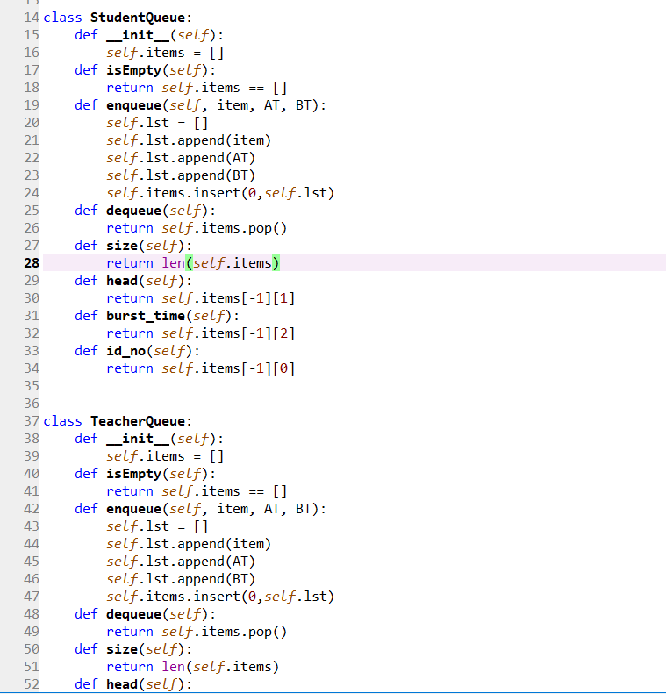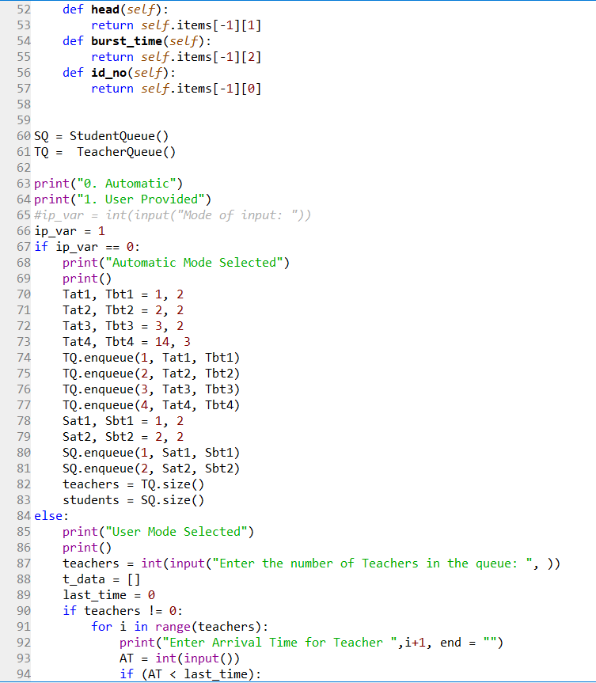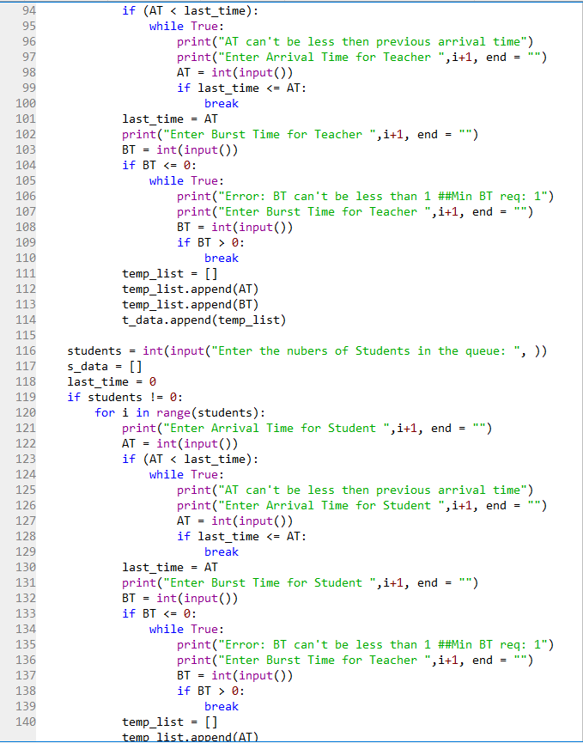

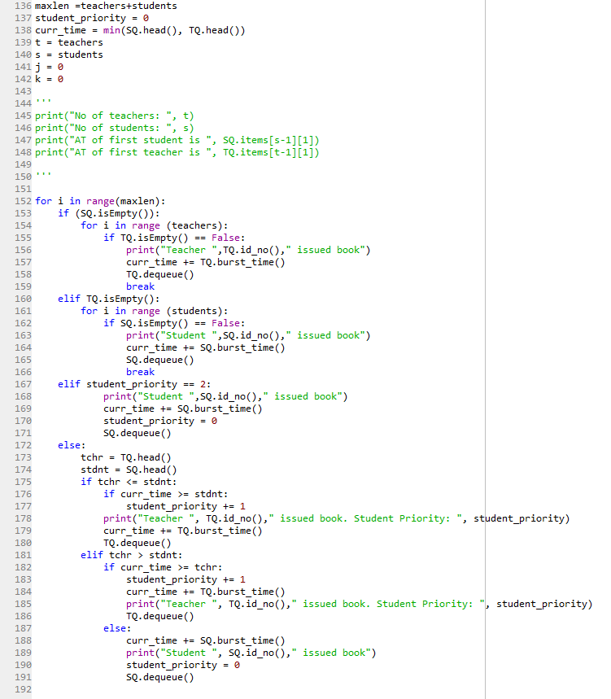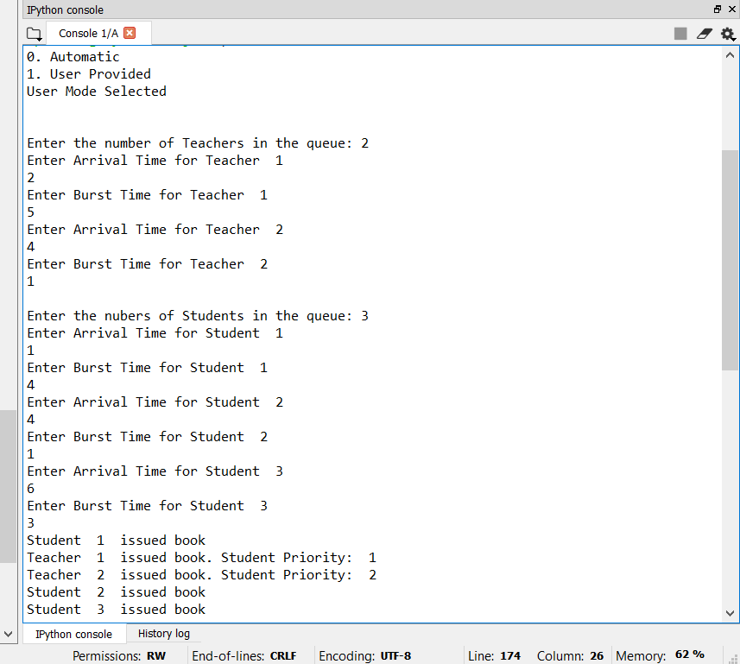

**Ques 5. If you implemented any additional algorithm to support the solution, explain the need and usage of same.**

**Description:**

Algorithm used in this code just iterates the ‘for loop’ for the length of the student queue and

**Ques 6. Explain the boundary conditions of the implemented code.**

**Description:**

If a Student and a teacher arrives at same after a Teacher than the student can only wait for one more Teacher only and after that Student will issue the book.

The Arrival Time for a Student/Teacher can’t be less than the previous Arrival Time.

The Burst Time for a Student/ Teacher can’t be less than 1 or 0.

**Ques 7. Explain all the test cases applied on the solution of assigned problem.**

**Description:**

|  |  |  |  |  |  |  |  |  |
| --- | --- | --- | --- | --- | --- | --- | --- | --- |
| **S.No** | **Condition** | | | | | | **Expected Result** | **Actual Result** |
| 1. | If 0 Teacher and N students. | | | | | | N Students issues book one by one. | N Students issues book one by one. |
| 2. | If N Teachers and 0 students. | | | | | | N Teachers issues book one by one. | N Teachers issues book one by one. |
| 3. | If N Teachers arrive at the same time and 0 students. | | | | | | The teacher which is in front of the queue will be served first. | The teacher which is in front of the queue will be served first. |
| 4. | If 0 Teachers arrive at the same time and N students. | | | | | | The teacher which is in front of the queue will be served first | The teacher which is in front of the queue will be served first. |
| 5. | If Arrival Time of any Student/Teacher is less than the previous Student/Teacher Arrival Time. | | | | | | It should re prompt the user. | It should re prompt the user. |
| 6. | If 3 Teachers arrive at the counter than 1 student arrives simultaneously with 3rd Teacher at the counter and after that 2 more teacher arrives. | | | | | | The student is served after the 4th Teacher. | The student is served after 4th Teacher. |
| 7. | If 3 Student arrive first and a Teacher arrives at the same time with 2nd Student at the counter and after that 4 more Student arrives. | | | | | | The teacher is served after the 1st student and the issuing goes on until the Student Queue is empty. | The teacher is served after the 1st student and the issuing goes on until the Student Queue is empty. |
| 8. | Total Teacher are 3  Total Student are 2  Taking BT[T/S] = 2 | | | | | | Teacher 1 issued book.  Teacher 2 issued book.  Student 1 issued book  Teacher 3 issued book.  Student 2 issued book | Teacher 1 issued book.  Teacher 2 issued book.  Student 1 issued book  Teacher 3 issued book.  Student 2 issued book |
| AT[T1] = 0  AT[T2] = 1  AT[T3] = 2 | | | AT[S1] = 0  AT[S2] = 1 | | |
| 9. | Total Teacher are 4  Total Student are 4 | | | | | | Student 1 issued book  Teacher 1 issued book.  Teacher 2 issued book.  Student 2 issued book  Teacher 3 issued book.  Student 3 issued book  Teacher 4 issued book.  Student 4 issued book | Student 1 issued book  Teacher 1 issued book.  Teacher 2 issued book.  Student 2 issued book  Teacher 3 issued book.  Student 3 issued book  Teacher 4 issued book.  Student 4 issued book |
| Tno  1.  2.  3.  4. | AT  1  3  4  10 | BT  2  1  2  3 | Sno  1.  2.  3.  4. | AT  0  1  4  7 | BT  2  1  2  1 |

**Ques 8. Have you made minimum 5 revisions of solution on GitHub?**

**GitHub Link:** <https://github.com/akhildhiman7/Student-Teacher-Problem.git>